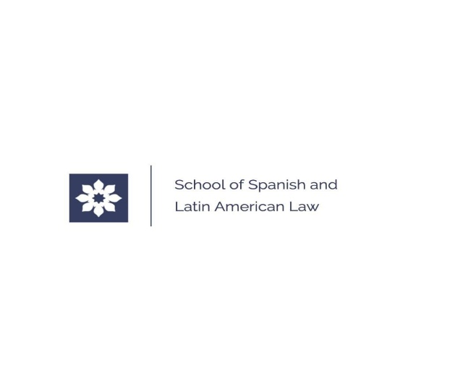
SUMMER SCHOOL OF SPANISH AND LATIN AMERICAN LAW

Edition " Derecho de la Sociedad Digital y Nuevas Tecnologías"

ADMISSION : until 15 June 2022.

Duration: 30 June to 2 July 2022.
Format: on line
Language: Spanish
Requirements for obtaining the Certificate: attendance at 80% of the sessions
Price: 500 PLN*/ 600 PLN
* students, PhD candidates, attorneys at law trainees

*ABOUT THE SUMMER SCHOOL

The Summer School has obtained the Honorary Patronage of the Spanish Embassy in Poland. The School has also Patronage of the International Chamber of Commerce of Barcelona, the Bar Association of Attorneys at Law in Gdansk and the Bar Association of Attorneys at Law in Alicante.

The students receive a Certificate of Completion at the end of the Summer School.

The School offers the opportunity to get acquainted with the working style of Spanish lawyers and businessmen and to develop the learning of the Spanish language and legal and business terminology.

*SPEAKERS

The classes at the School are conducted in Spanish by academic professors from Spain and Latin American countries (mostly from the University of Alicante, the University of Barcelona and the University of Cadiz), as well as professionals from the world of law and economics (including the Barcelona International Chamber of Commerce). The Honorary Professor of the School is Prof. Manuel Desantes Real (University of Alicante).

*STUDENTS

The Summer School are dedicated to students and graduates of universities, PhD candidates, lawyers, entrepreneurs, professionals (e.g. attorneys at law, legal advisors, translators) interested in subjects related to law, business and economics in Spain and Latin American countries in practical and theoretical aspects.

*PROGRAMME
(Upload)

The Summer School programme includes:

-Intellectual Property Law and new technologies.
-Copyright law in the digital environment.
-Internet and digital society law. Internet platforms and obligations of Internet service providers. The subject of distance contracting and e-commerce.
-Selected issues of Spanish civil law.
-Arbitration in commercial law and intellectual property cases.
-Legal aspects of Blockchain and Artificial Intelligence (AI).
-New business models in Spain and Latin America.
-Cybersecurity in business and selected issues of Spanish criminal law.
-Development of personal branding and customer relations in the digital environment.

*ADMISSION

The applications will be accepted until 15 June 2022.

The interested persons are kindly requested to send the email to sphl@ ug.edu.pl and to fill in the application form (attached at the web site).

The application form (scan of signed printout) should be submitted by email to: sphl@ug.edu.pl and by post to the university address (in original) : Faculty of Law and Administration of the University of Gdansk, ul. J. Bażyńskiego 6, 80- 309 Gdansk, with the note : School of Spanish and Latin American Law.

*COURSE FEE

The fee for participation in the Summer School of Spanish and Latin American Law is:
-500 PLN for students, doctoral students and trainee lawyers.
-600 PLN for all others.

Payments should be made before 31 May 2022 at the UG account No:
59 1240 1271 1111 0010 4368 2415
Bank PEKAO S.A. IV O/Gdańsk
Kołobrzeska 43

The title of the transfer should include : 506-P060-S697-22, first and last name(s), Spanish and Latin American Law School.

It is possible to : - to obtain the VAT invoice
- to pay in instalments according to the application submitted.

*CONTACT

dr Małgorzata Węgrzak, Director of the School
sphl@ug.edu.pl, tel.
University of Gdańsk
School of Spanish and Latin American Law ul. J. Bażyńskiego 6, 80- 309 Gdańsk

